Staging Site Changes – 29.10

1
Treatments Page
https://wordpress-1379640-6536820.cloudwaysapps.com/clinical-remedial-massage-practice-essendon/
Can you please make sure the headings and colours matches the heading on the website? Change these:
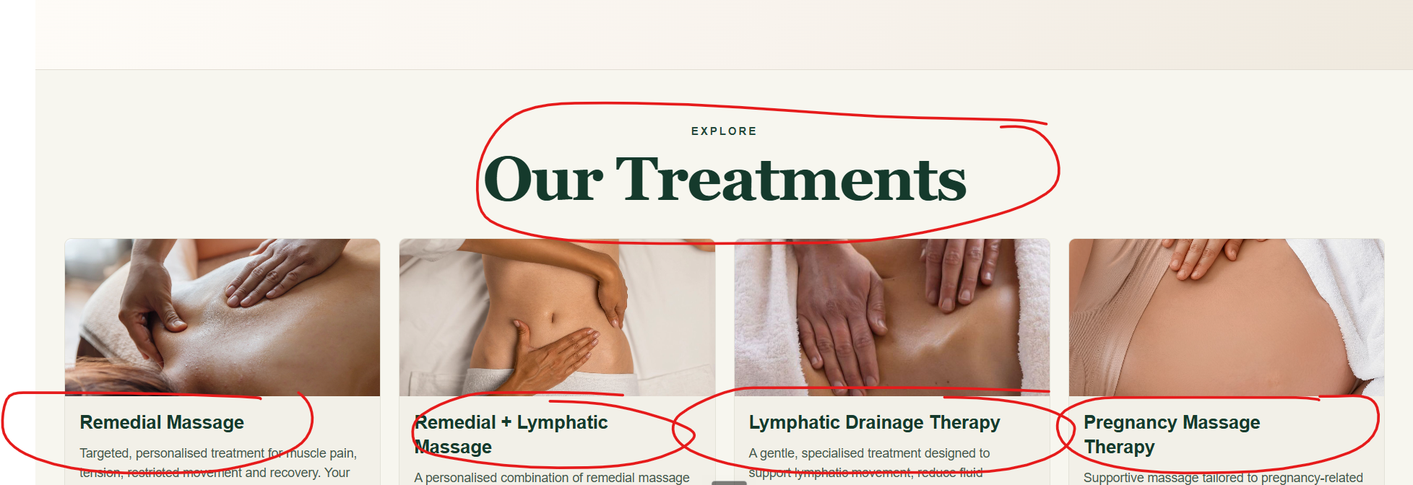

2
Top Banner
Change the font of this to Montserrat, the same font as the menu:
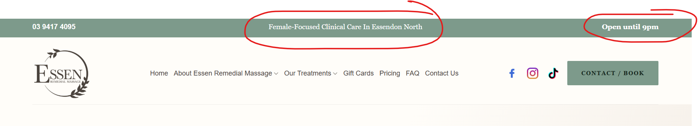

3
Change all button text colour to white
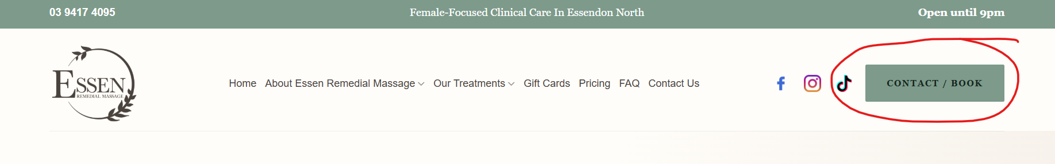
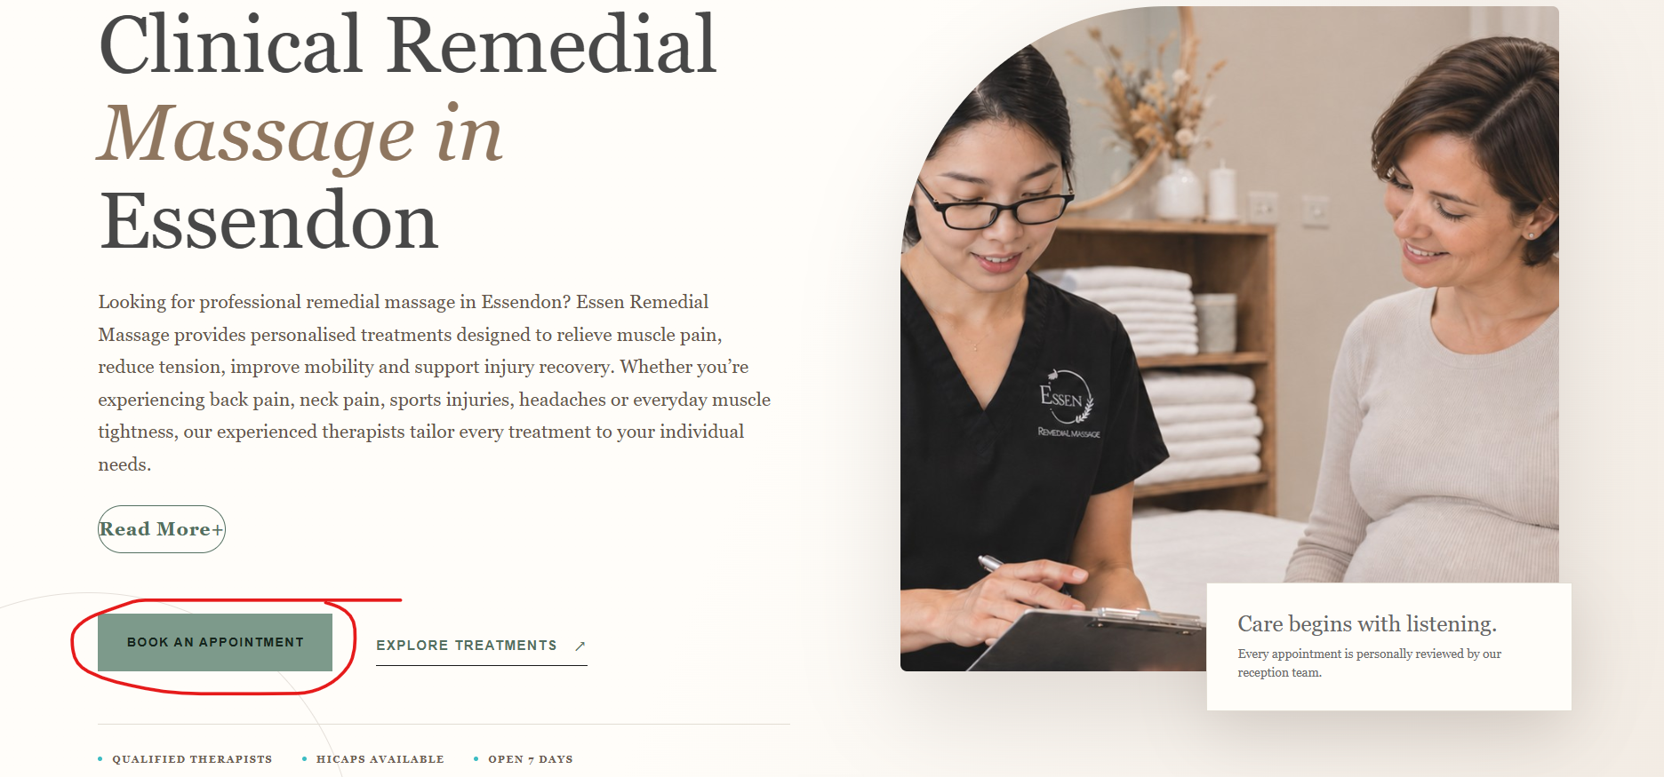

4
Read More button
Fix the Read More link format:
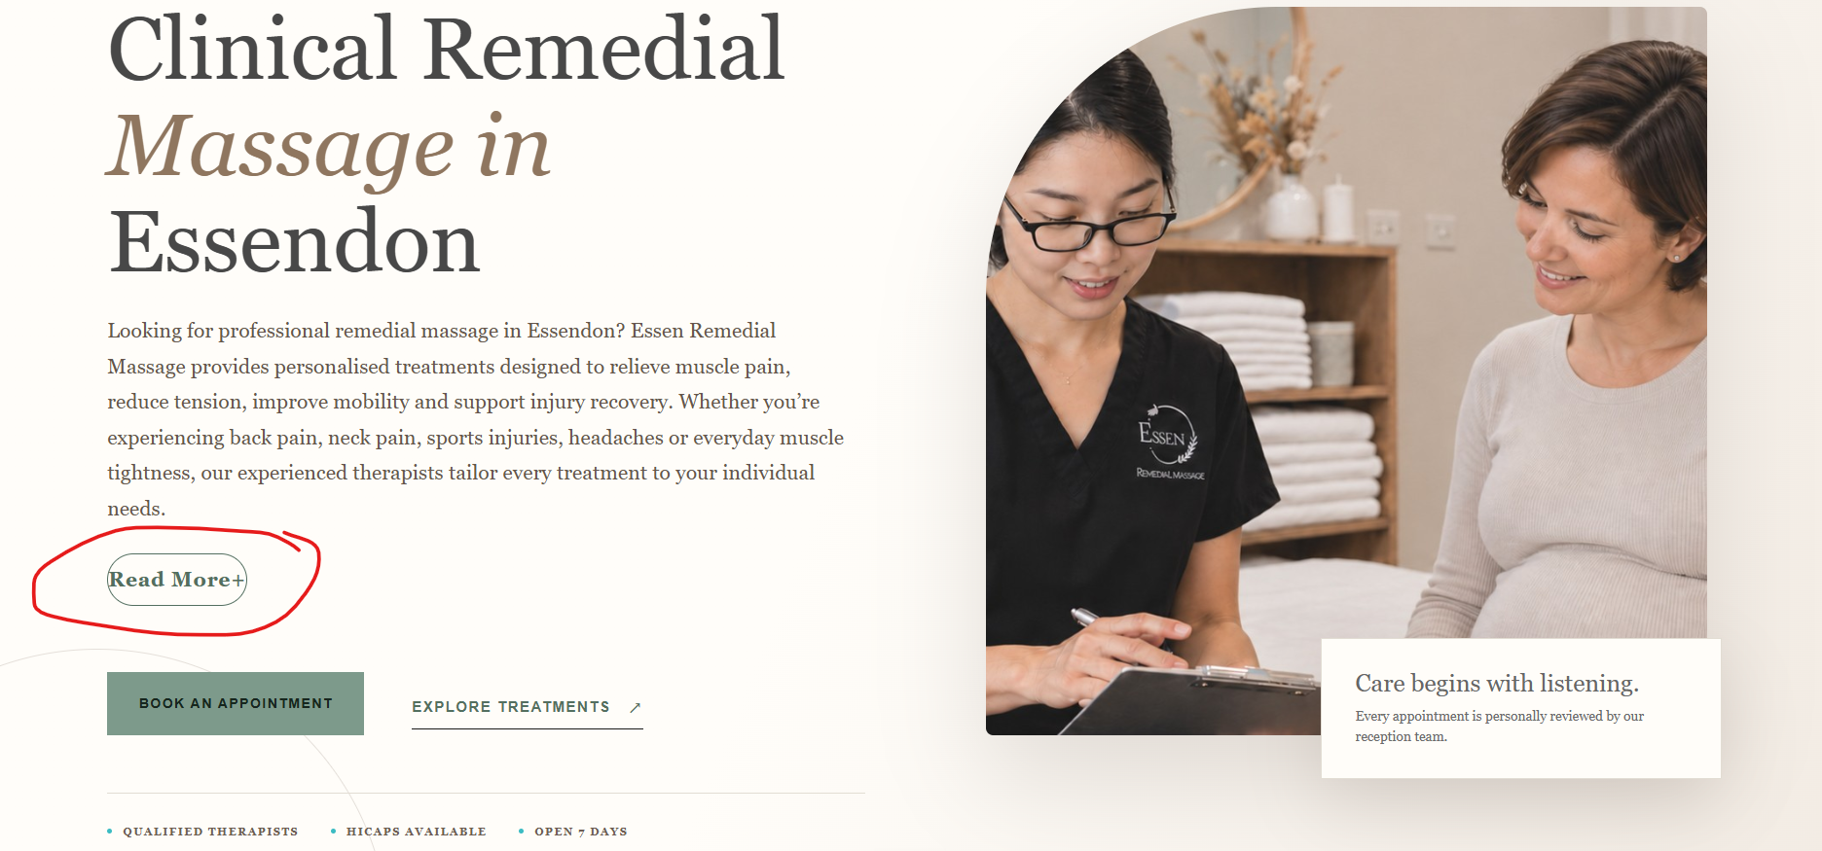
5
Pricing Page
https://wordpress-1379640-6536820.cloudwaysapps.com/pricing/
Change the header to match the headings on the site and change the colour to match the branding of the website (sage, cream, white)
Add a Book Now button below
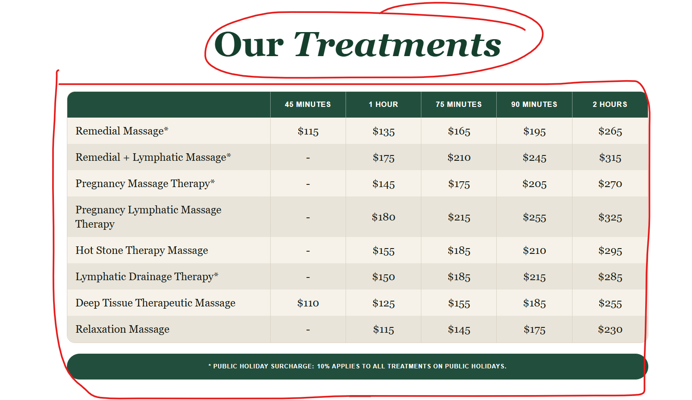
e.g
Reference layout, content and updated pricing from the customer. Follow the layout but keep our branding colours the same as the rest of the site:
- headers to be the same as the other headers
- table colour to be in sage green
- book your appointment to be the same colour as the one on the screenshot below)
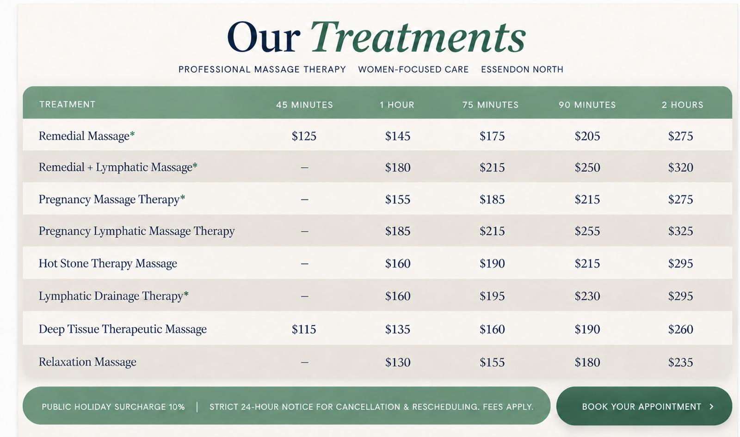
Make Book Now a button:
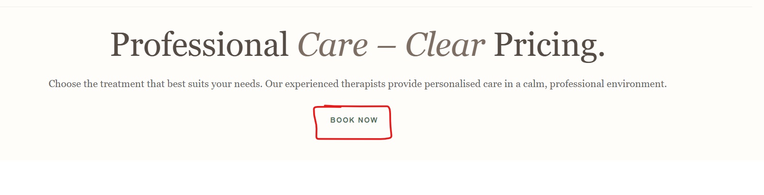

6
All FAQs
Change the FAQ image to the FAQ image attached.
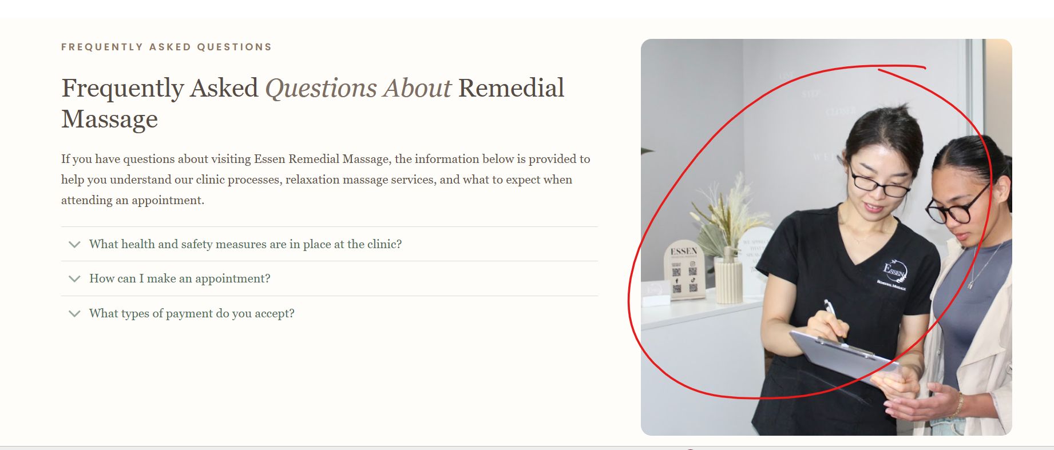
7
All Treatment Pages
Make “Contact Us” into a button:
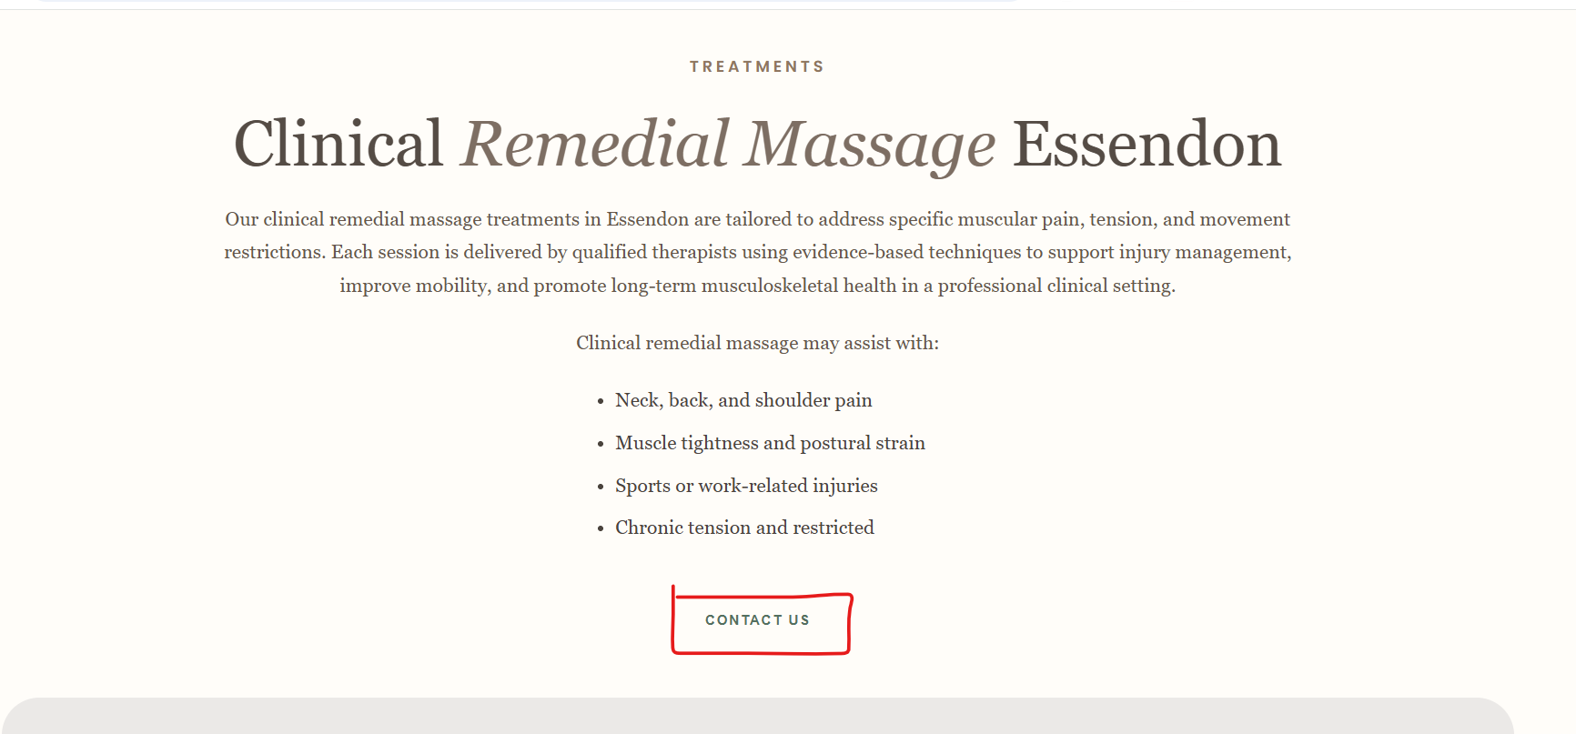
Only have the 1st paragraph visible and add a read more link to hide the other content sections on the banner.
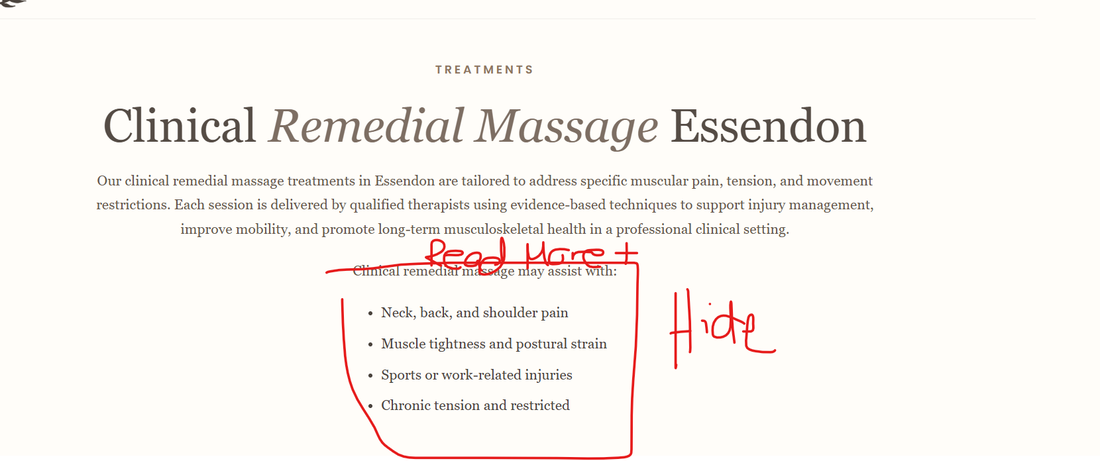
Change background of the testimonials as sage doesn’t blend well. Can you recommend a different colour.
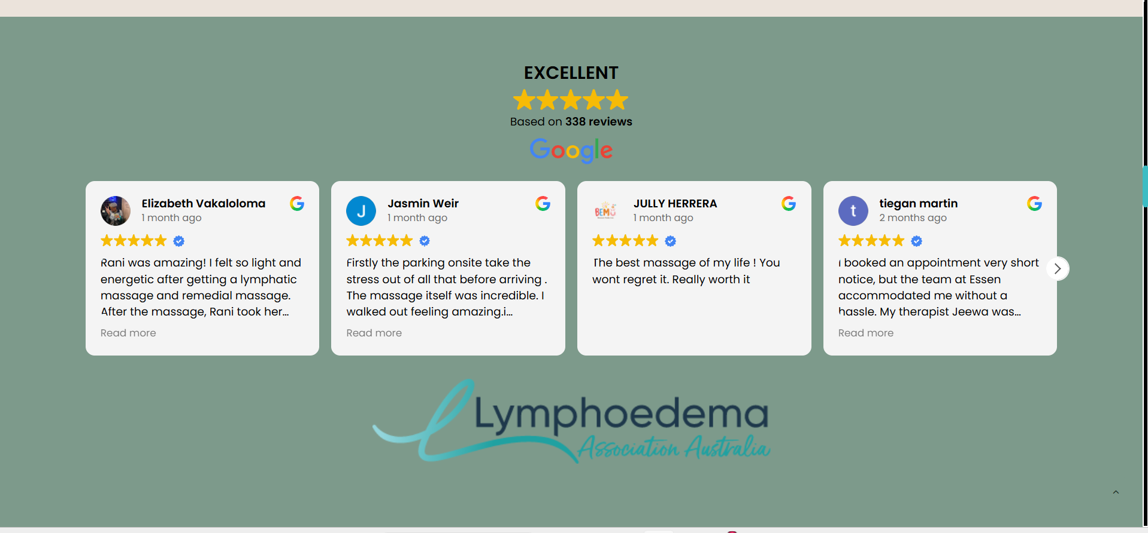
Change the FAQ image to the FAQ image attached.
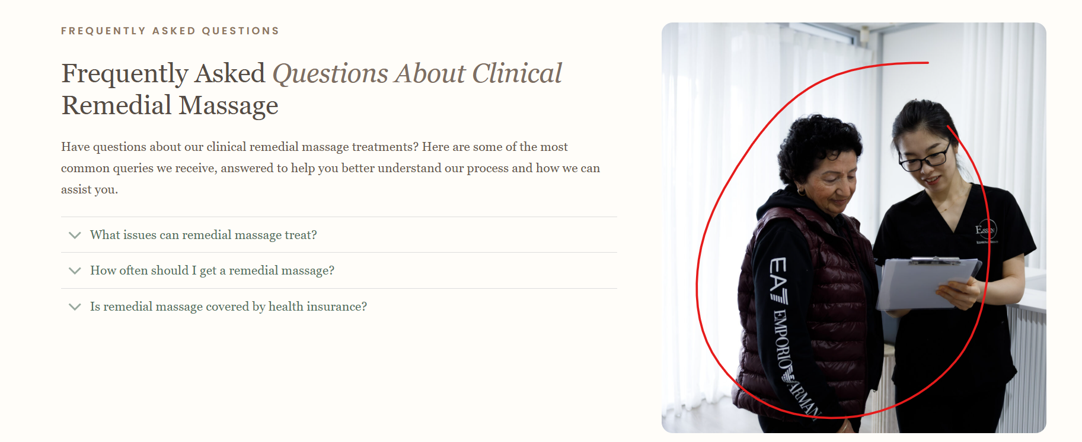

Change all pixelated Rani’s image to the new image I sent: _47A0449.jpg


8
Footer
Make the sage green background a little more darker to have contrast

9
https://wordpress-1379640-6536820.cloudwaysapps.com/our-treatments/clinical-relaxation-massage-essendon/
Remove this sage background:
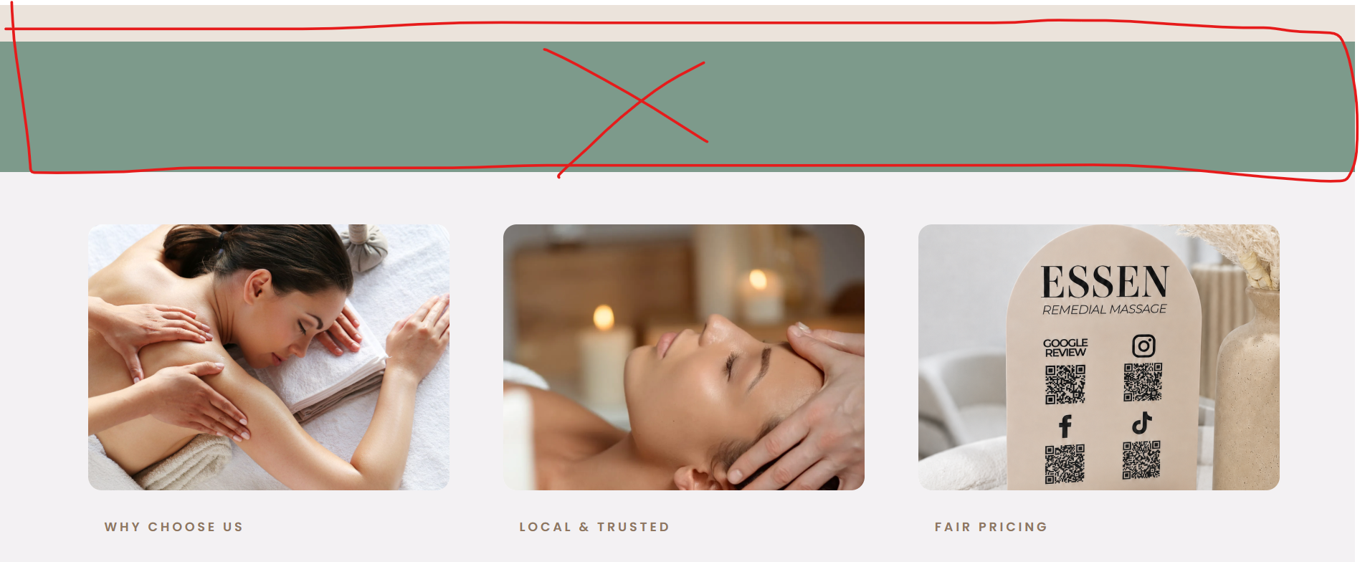

10
Contact Page
Change icons to sage green
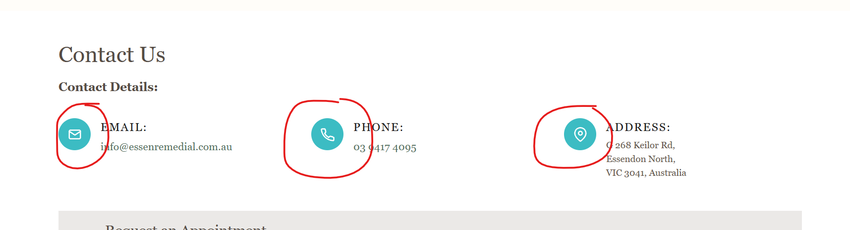

11
Gift Cards
Make button colours consistent
Sage background and white text:
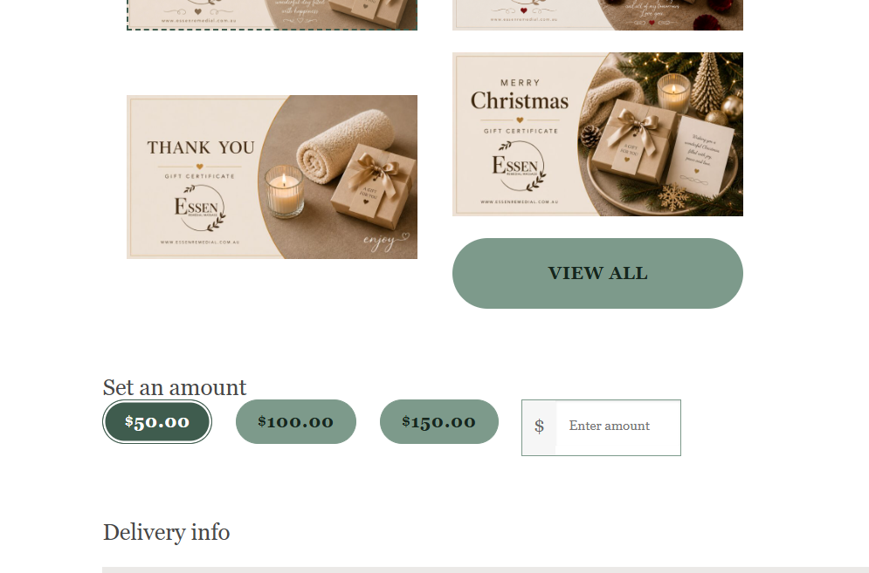

12
Home Banner Image
The customer would like to not crop the ladies in the photo. Is this possible? If we need to change the shape of the image, please do that.
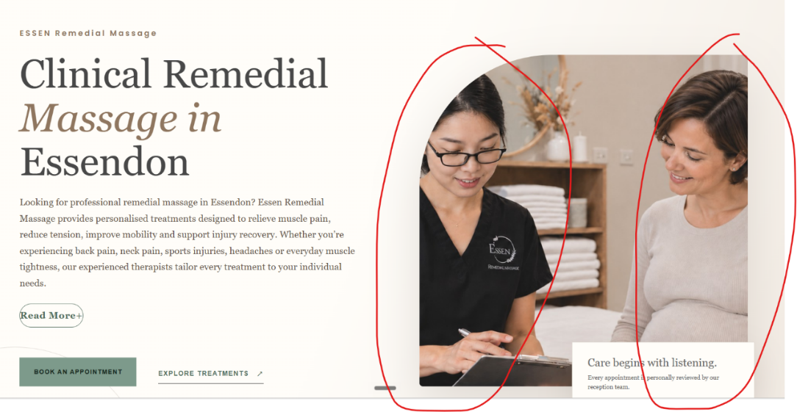
13
Pregnancy Lymphatic Massage Image
Can you try to generate an AI image similar to the style of the Pregnancy image:
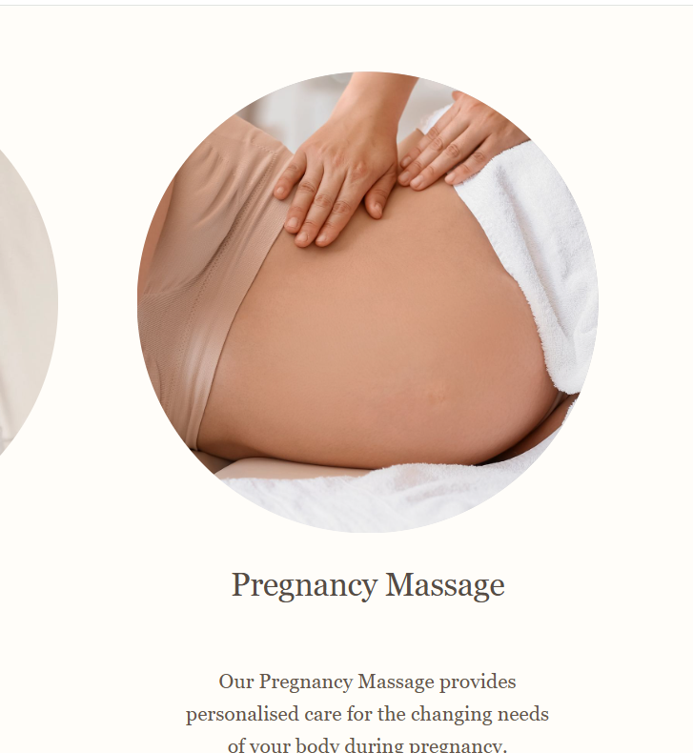
Change this image across the staging site:
